**Initial Diagnostic Exercises**

**SUBMIT HERE:** <https://classroom.github.com/a/5Vcmj5A_>

The purpose of this assignment is to get a self-understanding of your current skills. Keep this assignment for us to discuss if there are any items you face difficulty with.

This assignment is graded on **effort** **and completeness**, not correctness. If you’re unable to solve a problem, write any intermediate steps or related information that you do know. In the worst case, use pseudocode.

**Types**

1- Evaluate (Java):

* 5.0/2 = 3.5
* 10 % 3 = 1
* 3 / 3 + 5 * 3 = ? 16
* 2/3 = ? 1
* true || false true
* “Comp” + ”Sci” CompSci
* “10” + ”-1” 9
* “Belcalis Marlenis Almanzar”.charAt(2) Almanzar
* String elem = “hydrogen”; 7  
  elem.length();

**Conditions**

2- What does this code snippet print?

* + 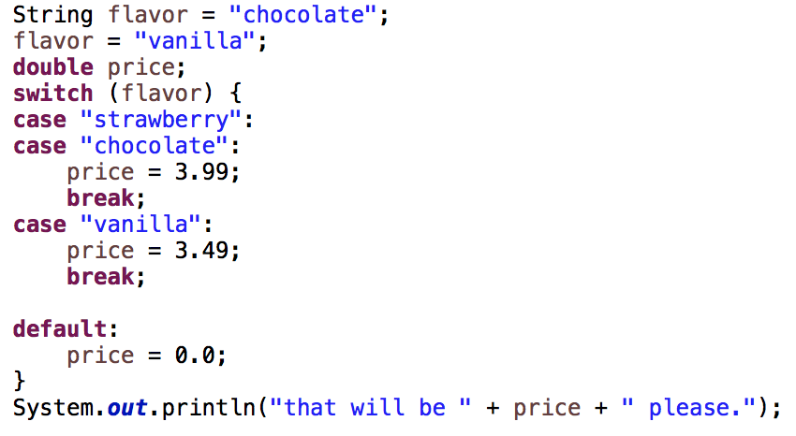
* What would the price be if the flavor was strawberry?

3.99

* What is the price for a pistachio?

0.0

3- Write a condition that is only true if an integer, x, is divisible by 4 or 7.

Int x;

if( x% 4 == 0){

system.out.println(“the number is divisible by 4”);

}

Else if( x%7 == 0){

system.out.println (“the number is divisible by 7”);

}

Else{

system.out.println(“the number isn’t divisible by 4 or 7, try again.”);

}

}

4- Are these two code snippets different? Why or why not?

* + 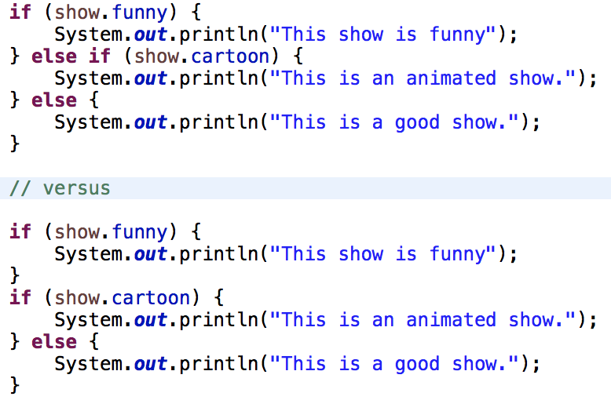

The first snippets will only print one of the if statements, while the second will print 2 statement.

**Loops**

5- Create a for loop that prints the *cubes (x3)* of all integers from -10 to 10

Int x;

for(x = -10; x< 11; x++){

Square = x*x;

cube= Square * x;

system.out.println( x+ “ “ square +” “ + cube);

6- What is the output of this snippet?

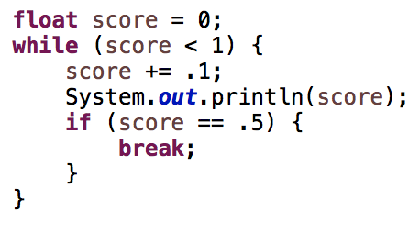

**It will print out 0.1**

**Functions**

7- Consider this function

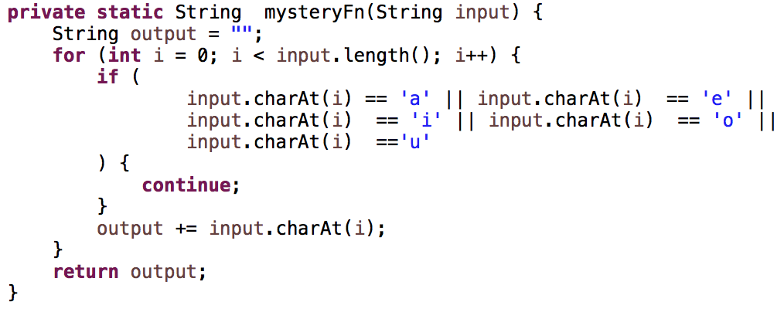

* + What is the return type?
  + It will print one the following ‘a’ ‘e’ ‘i’ ‘o’ ‘u’ and also find out how many vowels are there
  + What is the parameter type?
  + String mysteryFn
  + What does it do?
  + It print outs how many vowels in the lines
  + What is the result of mysteryFn(“Woah, we're half way there”)
  + The sentence will have 8 vowels.
  + Is there a case that it does not solve correctly?
  + If there a line were the vowels doesn’t apper.

**Arrays**

8- Write the implementation of a function that takes 2 arguments (an int array and two integer indices) and swaps the elements in the two indices of the array.

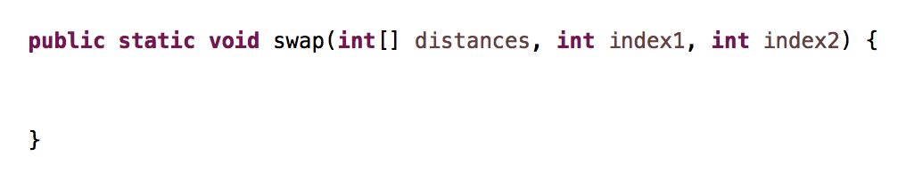

Public static void swap(int[] distances, int index1, int index2){

Int temp = distance [index1];

Distance[index1] = distances[index2];

Distance[index2] = temp;

9- Write a code snippet that prints the values in an array **backwards**.



for(int i=flags.length -1; i>= 0; i--){

system.out.println(flags[i] + “ “);

}

10- Write code that prints the values in the 3rd row of this 2D array

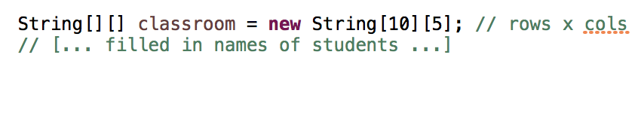

|  |  |  |  |  |
| --- | --- | --- | --- | --- |
|  |  |  |  |  |
|  |  |  |  |  |
|  |  |  |  |  |
|  |  |  |  |  |
|  |  |  |  |  |
|  |  |  |  |  |
|  |  |  |  |  |
|  |  |  |  |  |
|  |  |  |  |  |

for(int i =0; i< classroom.length;i++){

system.out.print();

for(int j = 0; j,classroom[i].length; j++){

System.out.print (classroom[i][j]);

**Objects and Polymorphism**

11- Consider this code and the following snippet;

Code:

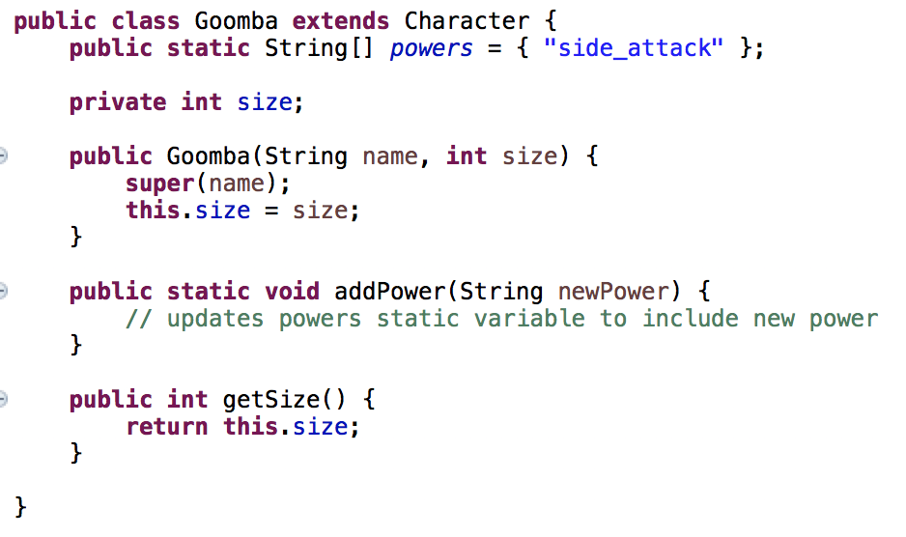

Snippet:

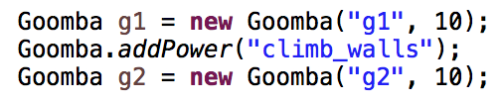

* What does the **super** call do?

The super is call to do method the parent class.

* What does this.size = size do?
* Is to clarify that size is equal to this.size only.
* What powers does g1 have at the end of the snippet?
* side_attack
* What powers does g2 have at the end of the snippet?
* climb_walls
* System.***out***.println(Goomba.*powers*) prints: [Ljava.lang.String;@6aaa5eb0

What is this value?

It will return N/A

12-

* What is an interface?
* An interface is a abstract type that contains a collection of methods and other type of variables.
* What is an abstract class?
* Is a class that declared abstract
* Why would you use one or the other?
* The use of the interface will use both abstract and other variable, so it will act like a guild while a abstract will be like a parent class.

**I/O**

13- Write a snippet that will read from input continuously until the user types ‘q’.

(refer to the attached Scanner API if you need to)

Scanner s = new scanner;

for( int i = 0; i < s.length; s++){

If (s == “q”){

system.out.println(“all done”);

Else{

system.out.println( s);

**Math Foundations**

14- Evaluate or Approximate

If you approximate, indicate if the actual value is greater/less than your approximation.

*Example: 1000/999 = little more than 1*

25/3 = little more than 1

10^-1 = less than 1

2^5 = more that 1(32)

3^4 = more than 1(81)

5^2 = more than 1 (25)

82^(.5) = less than 1

6! = more than 1

log(100) = more than 1(2)

log(1000) = more than 1 (3)

log(log(10000000000)) = equal to 1

**Recursion**

15-

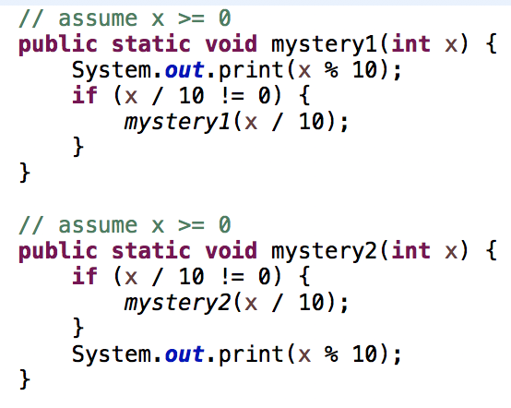

What is the value of:

*mystery1*(5678)? 0.08

*mystery2*(5678)?6.78